**Assignment: Monitor and Alert High AWS Billing Using AWS Lambda, Boto3, and SNS**

**Objective:** Create an automated alerting mechanism for when your AWS billing exceeds a certain threshold.

**Task:** Set up a Lambda function to check your AWS billing amount daily, and if it exceeds a specified threshold, send an alert via SNS. Below are the defined tasks created to complete the work.

**1. SNS Setup:**

**-** Navigate to the SNS dashboard and create a new topic.

- Subscribe your email to this topic.

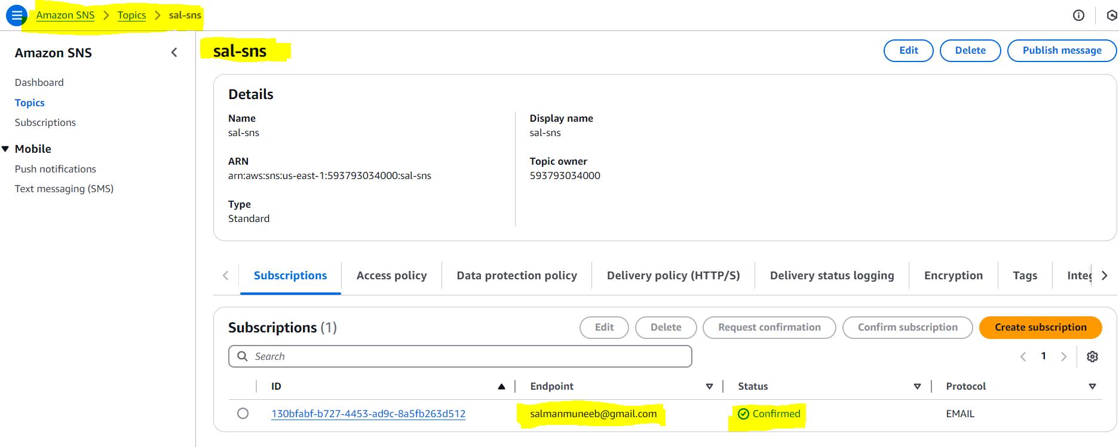

**2. Lambda IAM Role:** Attach policies that allow reading CloudWatch metrics, sending SNS notifications, Lambda execution roles and 1-inline policy also added to make it work.

- In the IAM dashboard, create a new role for Lambda.

- Attach policies that allow reading CloudWatch metrics and sending SNS notifications.

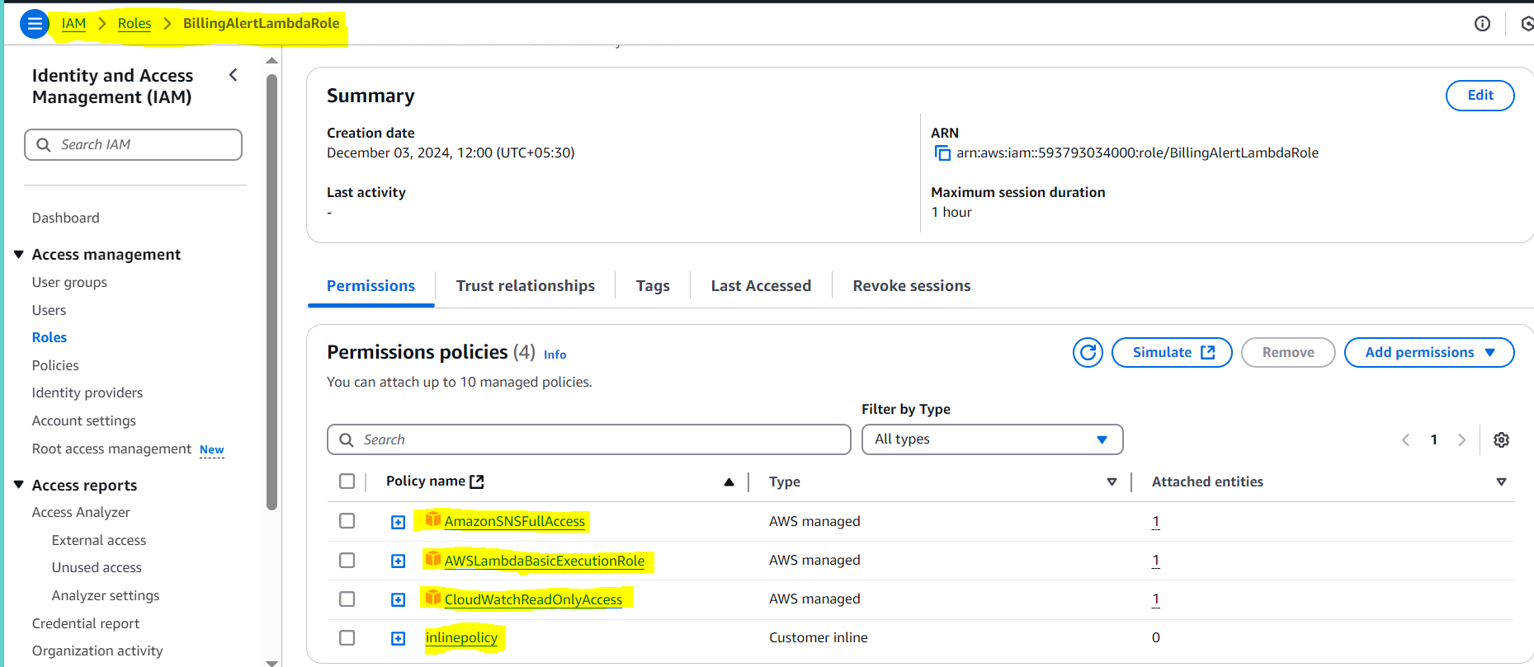

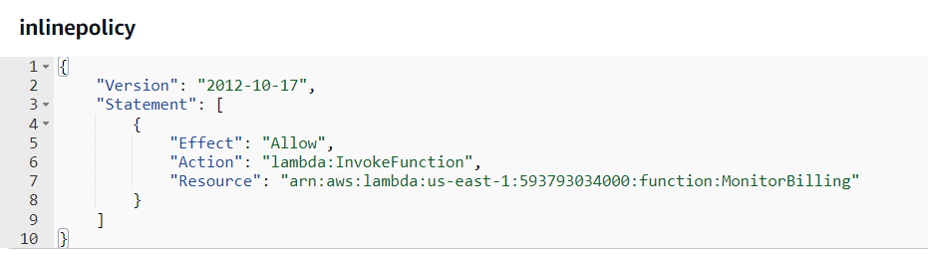

**3. Lambda Function:** Assign the IAM role created in the previous step and create the environmental variable for SNS ARN use in lambda function code using BOTO3.

- Navigate to the Lambda dashboard and create a new function.

- Choose Python 3.x as the runtime.

- Assign the IAM role created in the previous step.

- Write the Boto3 Python script to:

1. Initialize boto3 clients for CloudWatch and SNS.

2. Retrieve the AWS billing metric from CloudWatch.

3. Compare the billing amount with a threshold (e.g., $50).

4. If the billing exceeds the threshold, send an SNS notification.

5. Print messages for logging purposes.

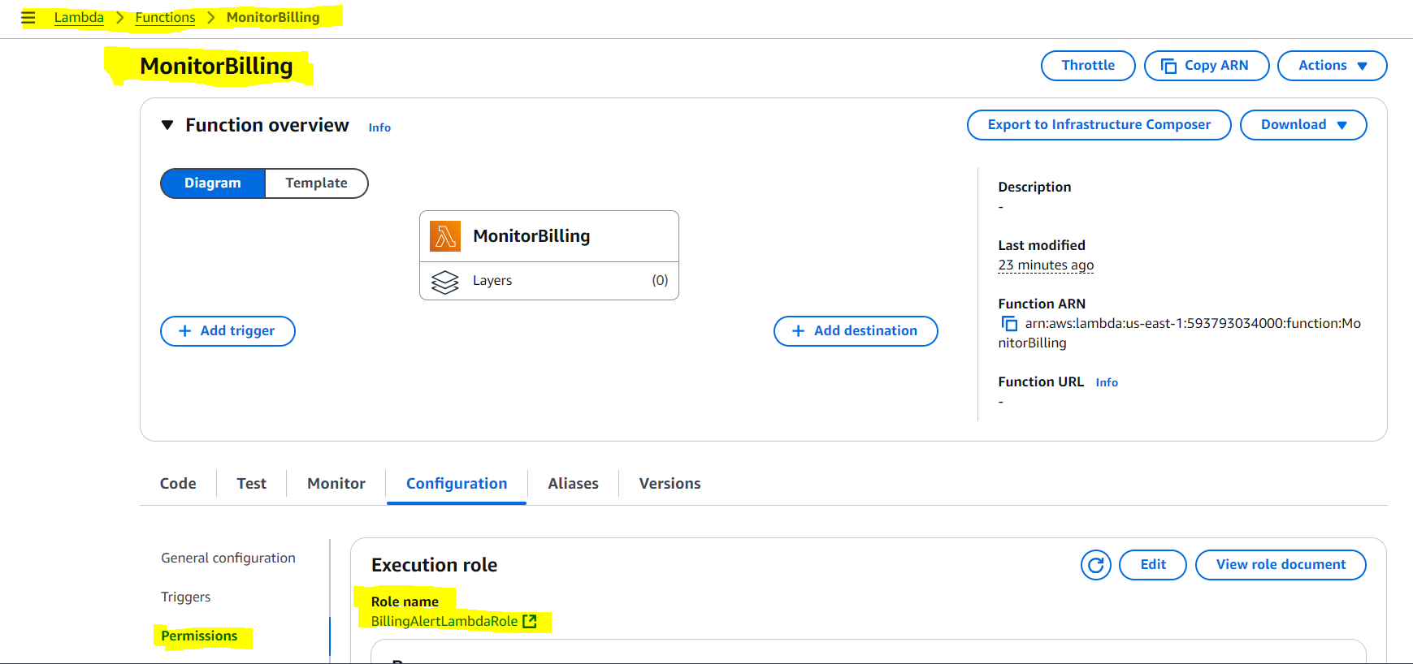

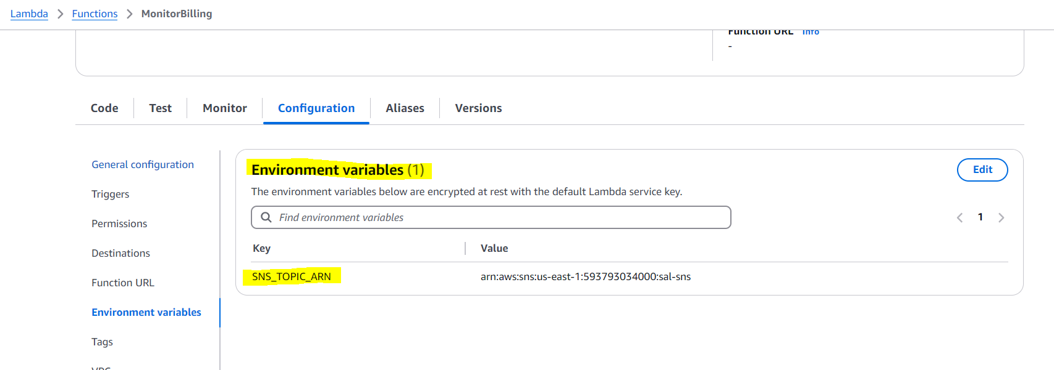

**4. Event Source created and after function runs log generated:**

***Note: I have put the threshold as 0.1 even though it does not cross (0.0 bill generated) accordingly no email came through SNS. But below is the snippet of the CloudWatch logs and billing metrics. Also created scheduler in the event bridge rule to run at a particular date and time and delete it automatically after the run.***

